  - Project Name: AI MECHANIC ASSISTANT
- Week: 1
- Topic: Introduction to Mobile Development
- Date: 09/06/2026

Weekly Objectives
- Install and configure Android Studio development environment
- Create a basic Hello World mobile application
- Customize app title, background color, and font size
- Add button with click listener and Toast message
- Run application on emulator

Activities Completed
- Project Creation
Created a new Android Studio project named AIMechanicAssistant using:
- Template: Empty Views Activity
- Language: Kotlin
- Minimum SDK: API 24
- Layout Design
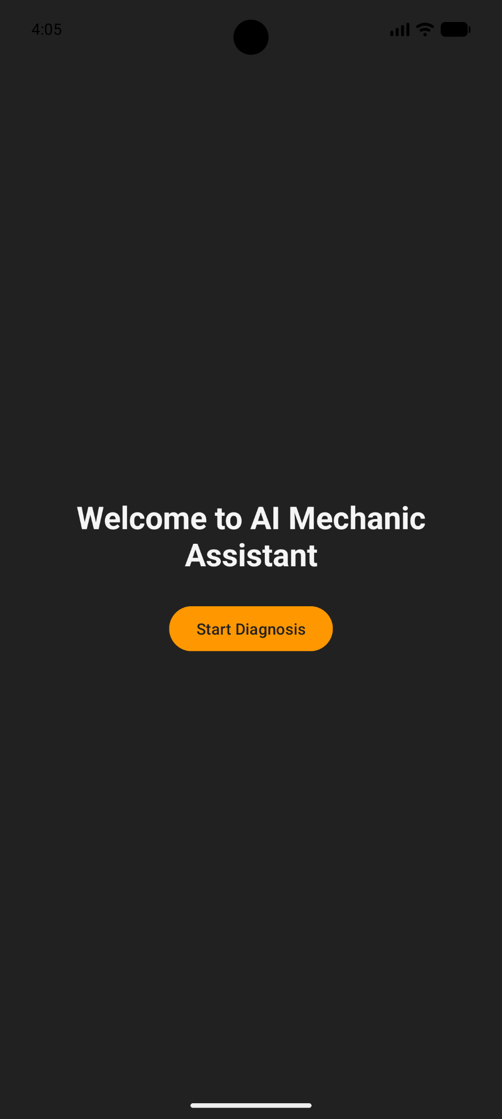
The running application displays:
- Custom welcome text at 28sp bold
- Start Diagnosis button with orange accent color
- Dark gray background representing automotive theme
- Emulator Testing
Created and ran Android Virtual Device (Pixel 9 pro API 33). App deployed successfully with custom automotive color scheme.

Challenges Faced
- Initial emulator setup required enabling hardware acceleration in BIOS
- Gradle sync took several minutes during first build
Solutions Implemented
- Enabled Intel HAXM for faster emulation
- Used offline Gradle dependencies for subsequent builds

WEEK 2
Weekly Objectives
- Implement Login and Registration screens
- Create Room database with VehicleEntity and Dao
- Build Vehicle list screen with RecyclerView
- Implement CRUD operations for vehicle management
- Test database persistence on emulator

Activities Completed
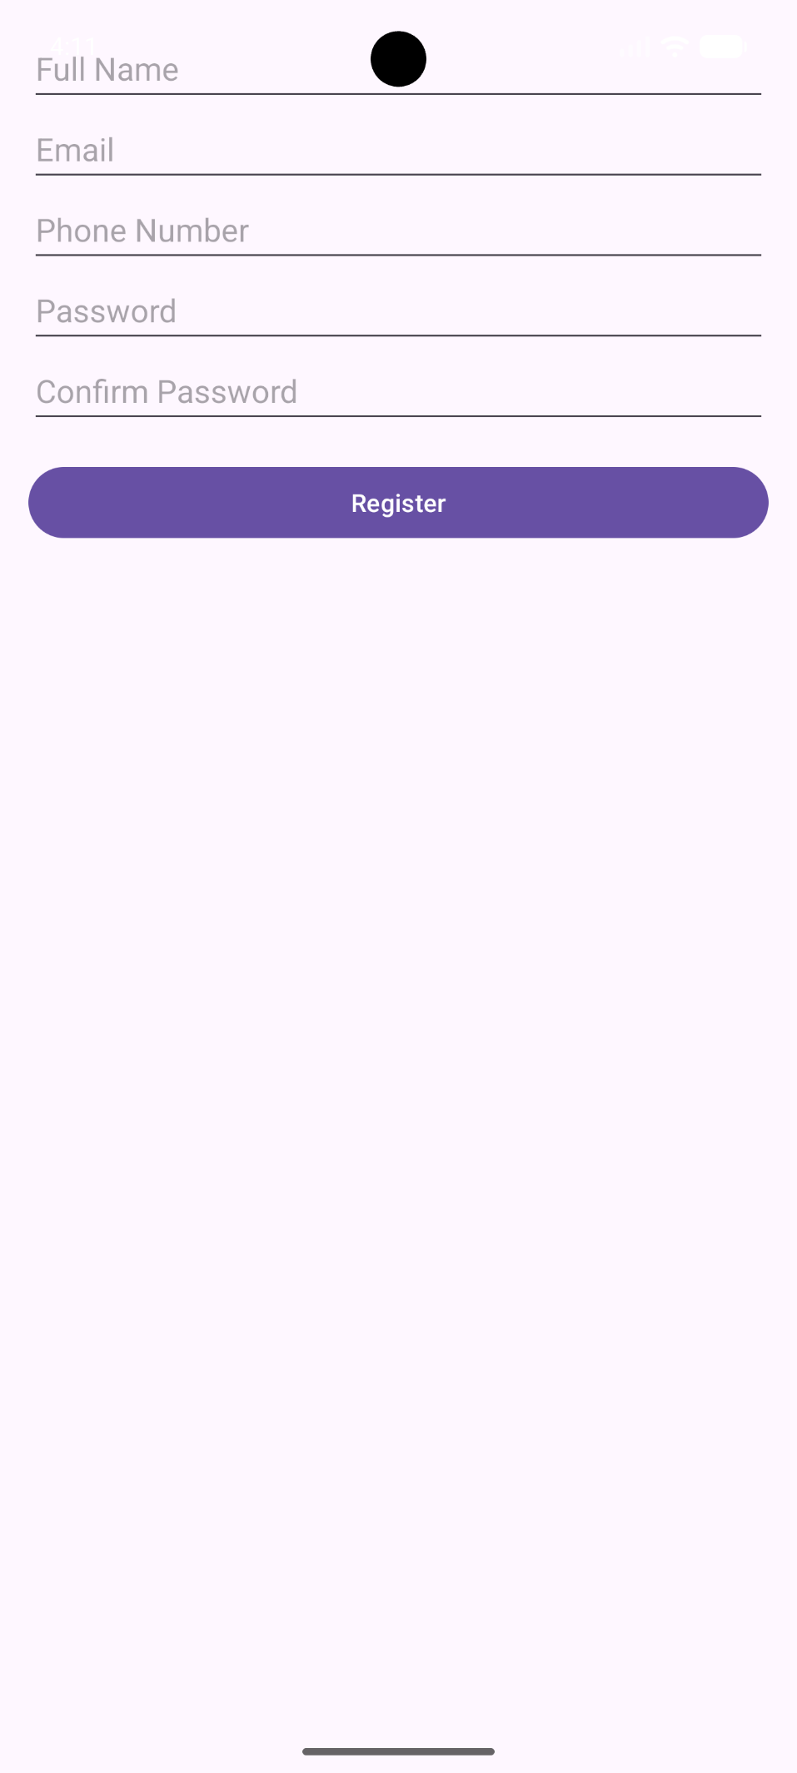
The registration screen includes:
- Full Name EditText
- Email EditText (textEmail inputType)
- Phone Number EditText
- Password EditText (textPassword inputType)
- Confirm Password EditText
- Register Button
4. Registration Screen with Keyboard
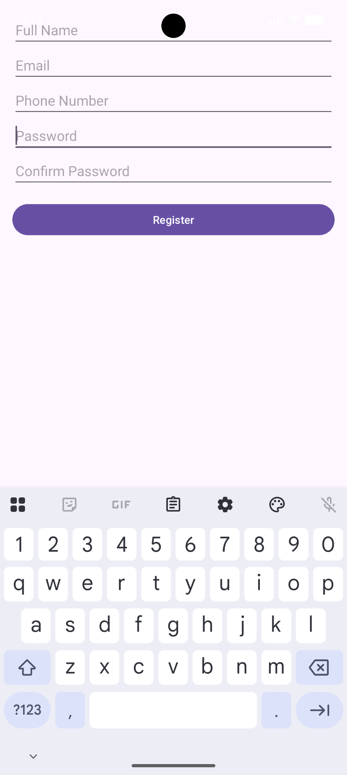
This demonstrates:
- Soft keyboard appearing on EditText focus
- Form validation active (password match checking)
- Responsive layout adjusting to keyboard
5. Room Database Implementation
Created the following database components:
- VehicleEntity – with properties: vehicleId, make, model, year, licensePlate, engineType, lastServiceDate, ownerUserId
- VehicleDao – Insert, Update, Delete, and Query methods
- VehicleDatabase – Singleton RoomDatabase instance
- DiagnosticRecordEntity – For storing AI diagnosis history
6. Vehicle List and Add Vehicle Screens
- Implemented VehicleListActivity with RecyclerView
- Created AddVehicleActivity with form fields for all vehicle properties
- Added navigation between Login, Register, Dashboard, and Vehicle screens

Challenges Faced
- Room database schema migration required careful version management
- KSP (Kotlin Symbol Processing) setup required additional plugin configuration
- RecyclerView adapter implementation required understanding of ViewHolder pattern
Solutions Implemented
- Used fallbackToDestructiveMigration() for development phase
- Added KSP plugin alias in libs.version.toml
- Created separate adapter class with proper ViewHolder pattern
WEEK 3 DOCUMENTATION
Weekly Objectives
- Design 7 XML layout files entirely within Android Studio (no external design tools)
- Create responsive layouts using Constraint Layout, Linear Layout, and weight distribution
- Implement custom automotive-themed colour scheme and typography
- Build navigation with BottomNavigationView and NavHostFragment
- Implement AI diagnosis logic with pattern matching for car symptoms
- Add gesture detection (swipe, double-tap, long-press)
- Implement maintenance reminders with notifications
- Test on physical device and tablet emulator

Activities Completed
1. XML Layout Files Created (7 Layouts)
2. Custom Colour Scheme (Automotive Theme)
Colour definitions created:
- primary colour – Deep blue (#1976D2) representing trust and reliability
- accent colour – Warning orange (#FF9800) representing check engine lights
- background colour – Dark grey (#121212) simulating a mechanic's garage
- surface colour – Light grey (#1E1E1E) for cards and surfaces
- error colour – Red (#F44336) for validation errors
- success colour – Green (#4CAF50) for successful diagnoses
- text_primary_colour – White (#FFFFFF) for readability
- text_secondary_colour – Light Grey (#B0B0B0) for hints and labels

3. Typography Styles
4. Main Dashboard Layout with Bottom Navigation
The dashboard includes:
- Welcome Card View displaying user name from Intent extra
- Statistics Card View with 3 metric cards using Linear Layout with equal weights
- BottomNavigationView with 3 destinations: Vehicles, AI Diagnosis, History
- Frame Layout as NavHostFragment container

5. Vehicle List Screen
Each vehicle card displays:
- Make and model (bold, headline1 style)
- Year and license plate (body2 style)
- Last service date with maintenance indicator
- Edit icon (pencil) and Delete icon (trash)

6. AI Diagnosis Screen
AI pattern matching implemented for:
- Battery/starting issues → "Dead battery or alternator failure" (85-95% confidence)
- Brake problems → "Brake pads worn or brake fluid low" (80-90% confidence)
- Engine codes (P0300, P0420) → "Engine misfire" or "Catalyst efficiency below threshold" (75-85% confidence)
- Overheating → "Coolant system issue or thermostat failure" (80% confidence)
- Transmission issues → "Transmission fluid low or solenoid failure" (70% confidence)
- Unusual noises (knocking, squealing) → Specific component diagnosis (75-90% confidence)
- Fluid leaks → "Oil leak from gasket" or "Coolant leak" (85% confidence)

7. Diagnostic History Screen
Filtering features:
- Spinner dropdown to filter by specific vehicle
- DateRangePicker to show diagnoses between selected start and end dates
- Export button to share history as text file

8. Settings Screen
Settings preferences:
- Default vehicle selection for quick diagnosis
- Dark mode toggle (AppCompatDelegate.setDefaultNightMode)
- Notification toggle for maintenance reminders
- Clear all history button with confirmation dialog
- Export all data button
9. Navigation Graph
The navigation graph defines:
- 3 top-level destinations (Vehicles, AI Diagnosis, History)
- 2 dialog destinations (AddVehicle, EditVehicle)
- Safe Args for passing vehicleId between fragments

10. Animation Files Created
Animations implemented:
- fade-in/fade-out – Fragment transitions
- slide up/slide down – Diagnosis result appearance
- shake – Edit Text validation error animation
- bounce – Button click feedback
11. Gesture Detection Implementation
Gestures implemented:
- Swipe right-to-left on AI diagnosis screen – Clears symptoms Edit Text and resets diagnosis result
- Double-tap on car engine Image View – Resets the entire diagnosis screen to default state
- Long-press on vehicle card – Opens bottom sheet with: Request Diagnosis, View History, Edit Vehicle, Delete Vehicle
- Long-press on diagnostic history item – Opens context menu with: Share via WhatsApp, Copy to Clipboard, Delete
- Swipe-to-delete on vehicle list – Deletes vehicle and associated diagnoses with undo Snack bar

12. Voice Input for Symptoms
Voice input features:
- Microphone button triggers Speech Recognizer
- Recognized speech automatically populates symptoms Edit Text
- Language support for English technical terms related to automotive issues

13. Maintenance Reminder Notifications
Reminder logic:
- Checks lastServiceDate of each vehicle
- Shows notification if last service > 6 months ago
- Shows notification if odometer reading > last service odometer by 5000km
- Notification channel created with importance HIGH
- Action buttons: Schedule Service (opens calendar), Remind Later (snooze for 1 week)

14. Physical Device Testing
Testing performed:
- USB debugging enabled on physical device
- Touch gestures tested (tap, long-press, swipe)
- Screen rotation tested – layout preserved using View Model
- Hardware back button tested – proper fragment back stack navigation
- Physical keyboard tested for form inputs

